**Submitted by Shrikant Lal**

**Roll number- R171218099**

**Submitted to – Dr Hitesh Kumar Sharma Sir**

**Experiment 3**

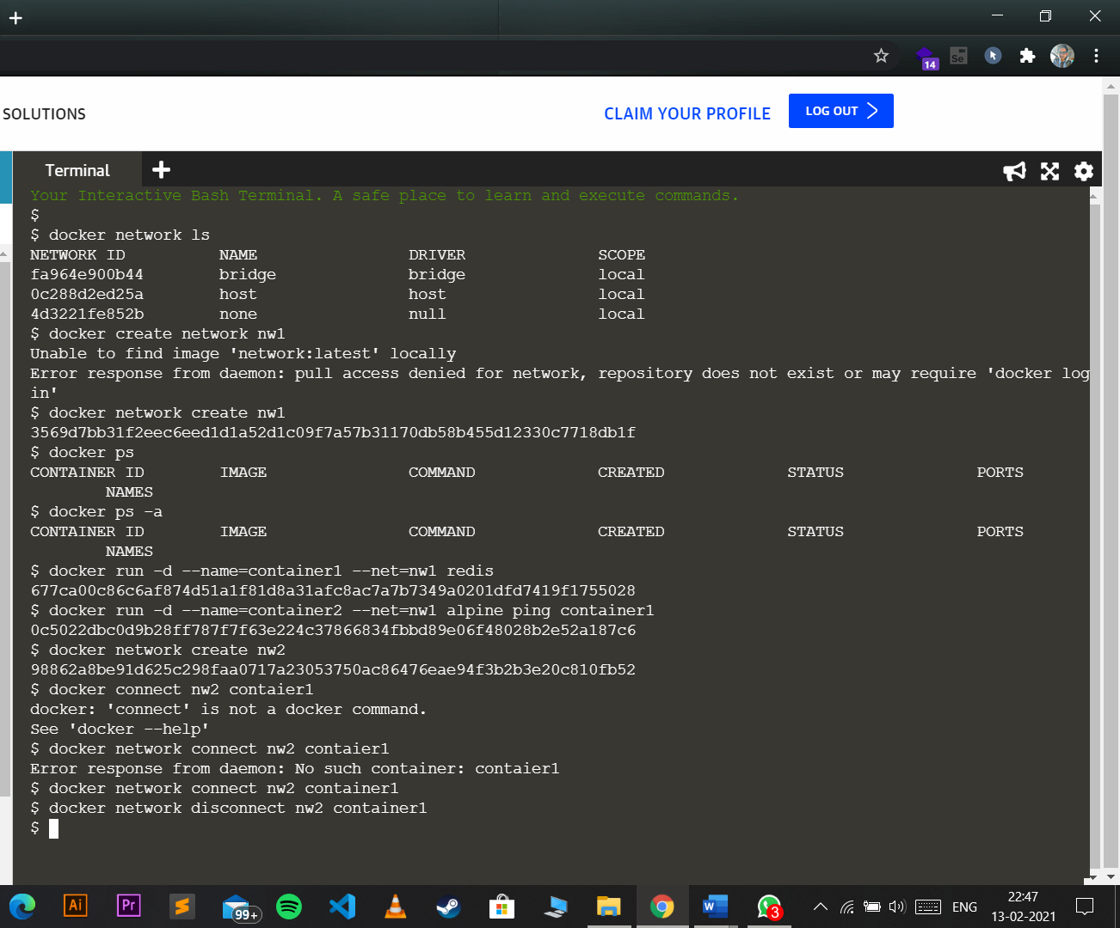

1. Create a network
2. List all the active networks
3. Create a container and connect it to the network created in step 1
4. Create another network nw2
5. Connect the container with network 2 also
6. Ping nw1 with nw2
7. Disconnect the network